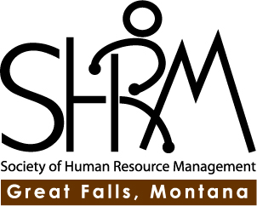
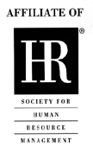

Thursday, March 21, 2013
11:30am – 1:00 pm
Charles Russell Museum
400 13 Street North

Please RSVP by Monday, March 18, 2013.

Email Marlena at mhalko@montanarefining.com

Meeting Cost for non-prepaid Members: $25.00

Speaker: Herb Byers, Montana State Fund
“Characteristics of a Safe Organization”

His presentation will address cultural issues, management styles, employee empowerment, behavioral modeling, positive reinforcement, behavior observation and coaching, effective safety training and hiring practices.

